**Name :- Shantanu Rana**

**Sap Id :- 500082398**

**LAB EXERCISE 2**

**Write a program in java to find sum of two numbers and test this unit with JUnit tool.**

**Step 1:- First I created a Maven Project and created a Class for sum of two numbers.**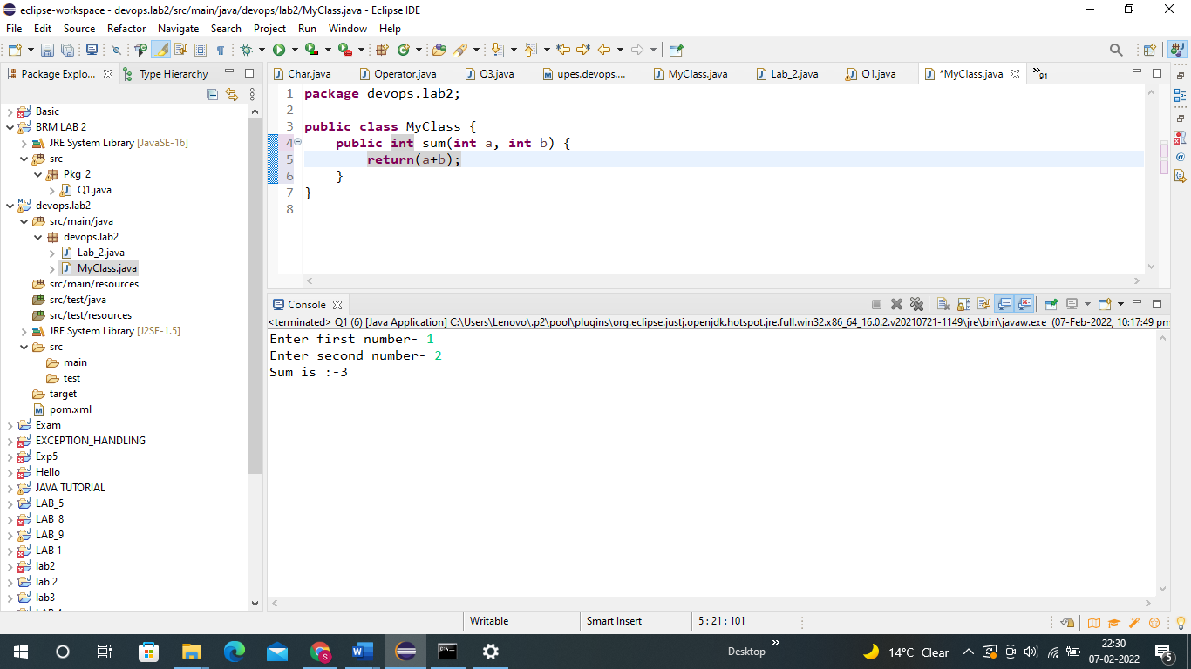

**Code:-**

**package** devops.lab2;

**public** **class** MyClass {

**public** **int** sum(**int** a, **int** b) {

**return**(a+b);

}

**Step 2:- Click on new and then on Junit Test Case**

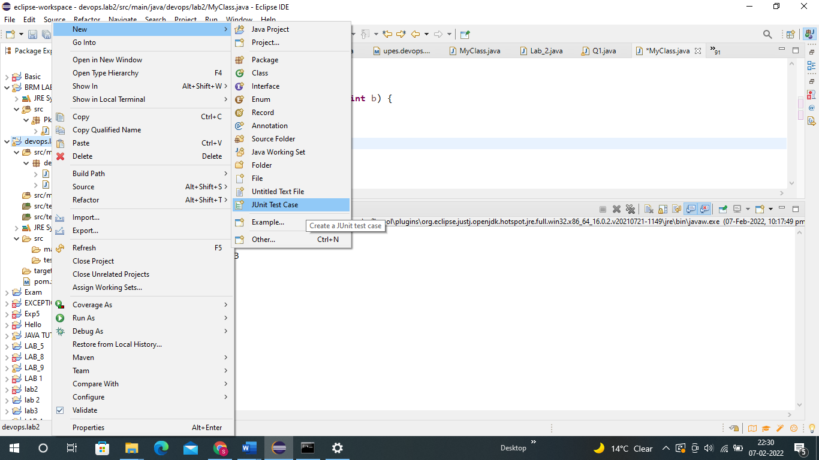

**Step 3 :- Now Add the Class Name and click on finish.**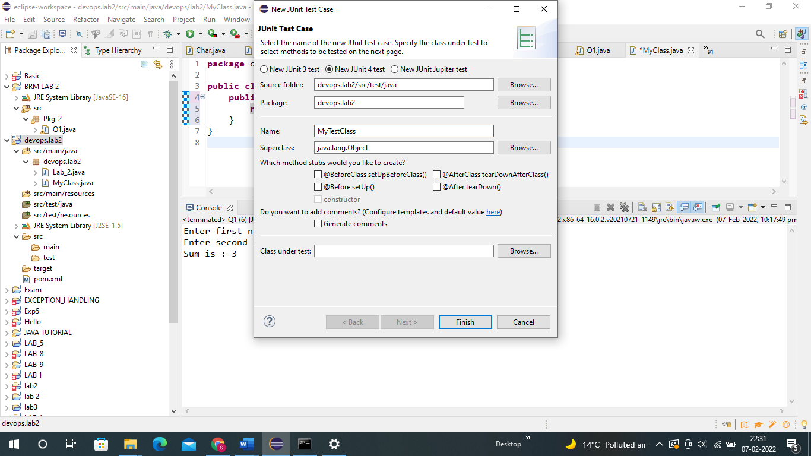

**Step 4 :- In this step a code we can already see a code but we will do some changes for our test.**

**we will see some code already written but we will change the line under function test and give the inputs. Updated Code is given below.**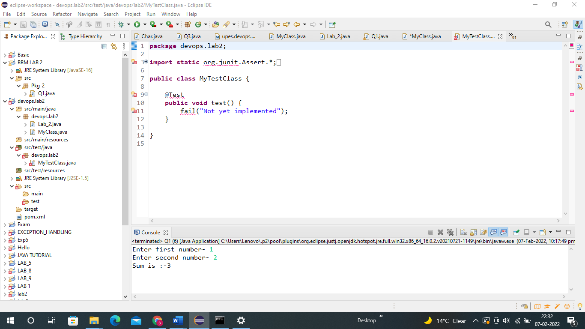

**Code :-**

**package** devops.lab2;

**import** **static** org.junit.Assert.*;

**import** org.junit.Test;

**public** **class** MyTestClass {

@Test

**public** **void** test() {

MyClass obj = **new** MyClass();

*assertEquals*(14,obj.sum(10, 4));

}

}

**Step 5 :- Now by right clicking on our project and then Run as and then click on Maven test.**

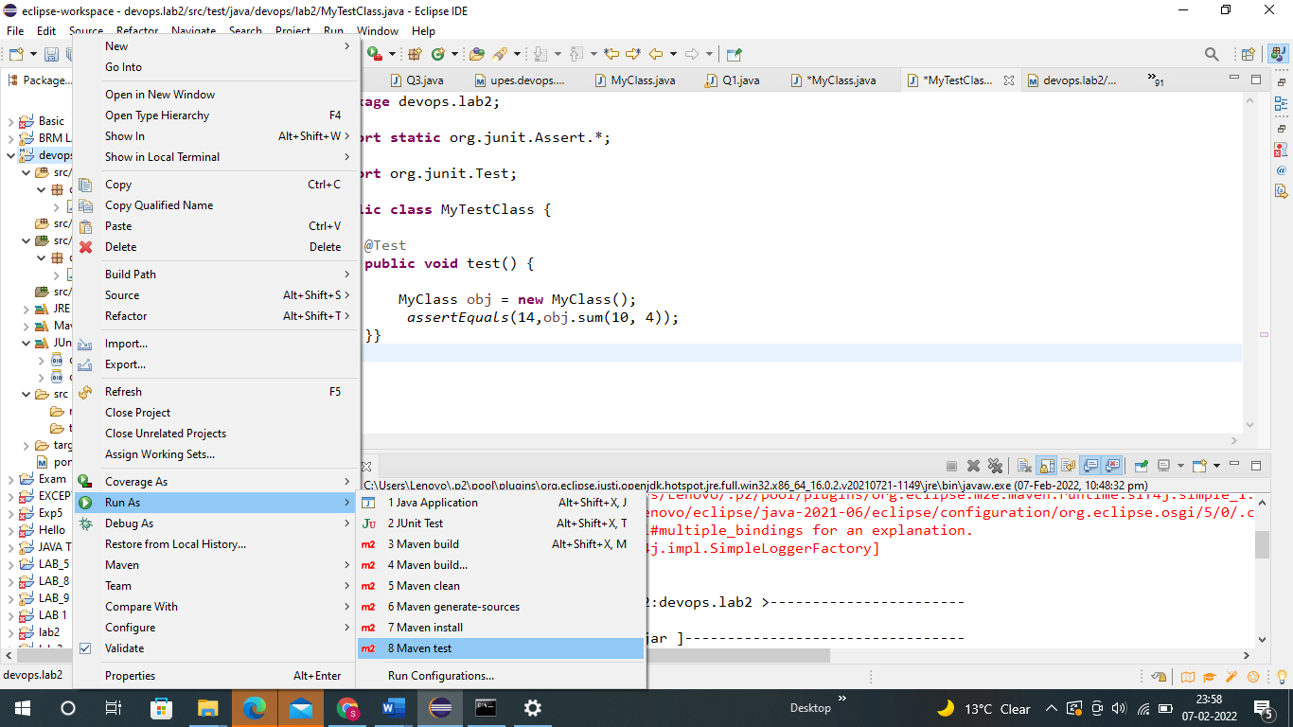

**After compiling we will see many errors first is the error of the java version for which we will add the given dependency in Pom.XML file.**

<properties>

<maven.compiler.source>1.8</maven.compiler.source>

<maven.compiler.target>1.8</maven.compiler.target>

</properties>

**And for the another error we will add the given dependency on Pom.XML file.**

<dependencies>

<dependency>

<groupId>junit</groupId>

<artifactId>junit</artifactId>

<version>4.12</version>

<scope>test</scope>

</dependency>

</dependencies>

**Step 6 :- Now again we will Execute our Junit test.**

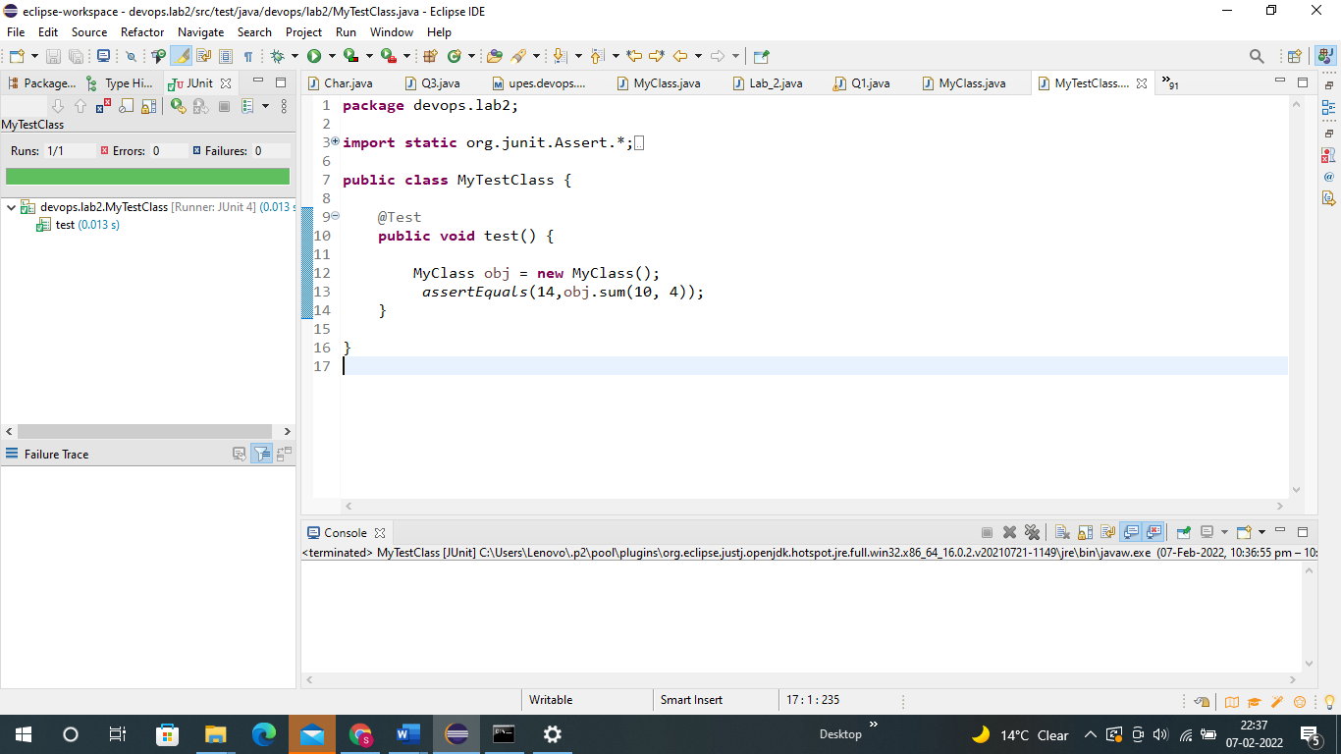

**Now we can clearly see that the it is done successfully as we can see the green colour and it’s written Run 1/1 , Errors :0 and Failure :0**

**Step 7 :- Now as we want to check it using maven so we will right click on the class and then on Run As and then on Maven test.**



**WE can see the output and it says Build SUCCESS.**

